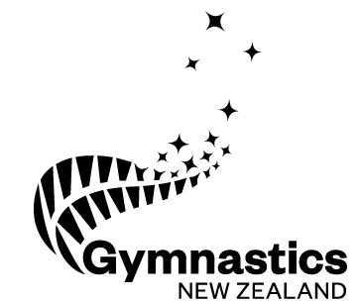
GymSports New Zealand Inc.
Trading as Gymnastics New Zealand
2024 Annual General Meeting

NOMINATION FORM

National Service Award
Meritorious Award

All nominations for a National Service Award / Meritorious Award must be submitted to the national office for the attention of the CEO by 5:00pm Tuesday 7th May 2024

Only Member Clubs are entitled to make nominations for these awards.

Please complete all parts of the form and ensure it is signed by the nominator.

Part A: Nominator Details

Name of Member Club:

Hereby nominates:

For the award of:

Position held in Member Club:

Date:

Part B: Nominee Details

These details need to be completed by the nominator and returned to the Member Club for submission with the rest of this form.

Name of Nominee:

Address:

Contact Numbers: | Home:
 | Business:
 | Mobile:

Date of Birth:

Occupation:

Please fill in the following OR attach a Curriculum Vitae.

National Service Award – please provide details for how the person has given service to gymsports in respect of a project or event.

General – any other comments you wish to have considered

Meritorious Award – please provide details for how the person has given service to gymnastics which warrants recognition beyond that provided for in Service Awards.

General – any other comments you wish to have considered

I, [name] hereby nominate the individual listed on this form to be considered for a National Service / Meritorious Award.

Signature of Nominator:

Date:

Please make sure you take a copy of this document and all other attached documents for your files, and then send the completed form with all attachments directly to:

Gymnastics New Zealand
office@gymnasticsnz.com
PO Box 948
Newmarket
Auckland 1149

