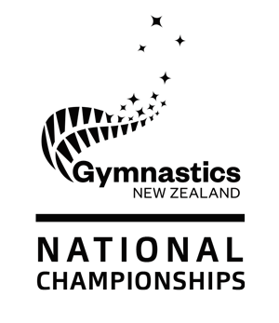
Application for Withdrawal – All Codes

If the athlete is withdrawing their entry from the 2019 New Zealand Gymnastics Championships for medical reasons, they will be eligible for a refund. This refund will be based on 80% of the entry fee and will only be processed once the Manager/Provincial Coordinator has submitted this form complete with the athlete’s medical certificate to Gymnastics New Zealand. No other refunds will be given for other costs/fees incurred by entering the 2019 New Zealand Gymnastics Championships, or for non-medical withdrawals.

Please submit medical certificates and this form no later than Wednesday 16 October. Refunds will not be processed after this date. Please send all documents to leanne.olsen@gymnasticsnz.com

- Applicant Details
ATHLETE’S NAME

province & CLUB
GYMNASTICS CODE
COACH/MANAGER

- Application
item 1 | What is being applied for and the reason for the application?
item 2 | Relevant medical information and certification (please attach medical certificate)
item 4 | Any other information

- Decision

item 1 | Decision and Reason – Gymnastics New Zealand use only

