2020 Ollerup Scholarship

January to June (23 weeks)

FAQ and Information

What is Ollerup?
The International Academy (INTAC) is an integrated part of Gymnastikhojskolen I Ollerup - a Danish Academy offering non – formal education with a special focus on Gymnastic. Students are between Ollerup of 18-30 years (Must be 18 by the 31st of December 2019) this scholarship is for the First Semester (spring semester) and is for 23 weeks (5.75 months). As a student you will eat, study and sleep at Ollerup spend most of your time at the school. As this course is completely practical there are no exams but on the completion of close stay you will be presented a certificate as a proof of your attendance.
Classes are based on dialogue and mutual learning between teachers and students. One focus is to discover and strengthen the unique skills of each student in a challenging yet supportive social atmosphere. Another focus is to provide knowledge and skill for becoming trainers and leaders in sport and voluntary organisations. Sports – especially gymnastics – are thus not considered as an aim in itself, but also as a mean of education, aiming personal development as well as making the students more harmonious human beings and active citizens.
As a students an International Academy, (INAC) you get an International youth leader education (IYLE). The IYLE course is in constant development, We aim to give you the best ‘tools’ for your future life. For example, we will use sport as a media for achieving skills that are vital in the modern world: international competences, coaching, team building, supervision, co-operation, leadership, event planning and management among others.

Programme/ Syllabus
Many of the classes are integrated with Danish students. The theoretical lessons will be taught in English while the practical lessons will be a mix of both English and Danish.
  - Course Content:
- Gymnastics; divided into different lines (you choose one): TumblingX (Performance Tumbling), Parkour/ free running, Danish Rhythmic Gymnastics, Team Gym and Power Tumbling
- Sports – (swimming, Ball Games; nature and outdoors activities)
- Inter Culture Studies; Students are introduced to Denmark, the background and values of Scandinavian welfare society and relevant societal topics from around the world.
- Leadership Class, LUP – Learning, Development and Perspectives (coaching exercise, theory, project work, methods of instructing etc.)
- Danish Language; enable students to communicate on a basic level with native Danish speakers
- NGO (Non-Government Organisation) World/Management ; an introduction to the world of volunteer organisation, sports association, non-governmental organisation as well as general knowledge about project work
At the Gymnastikhojskolen I Ollerup all subjects and lessons are equally important. The overall idea is placed on holistic development and in order to gain such and experience it is important that students show interest in all their lessons and not only focus on particular subjects. It is mandatory that students are present (both physically and intellectually) at every lesson. Example of a schedule:

Example of Timetable
Time/ Day | Monday | Tuesday | Wednesday | Thursday | Friday
7.10 am – 7.30am | Breakfast
7:30 am – 7.50am | Morning Duties / cleaning
8.00 am – 8.20am | Morning Assembly |  |  | 8:00 – 9:30am  Gymnastics, Dance and Leadership | Morning Assembly
8.30am – 9.45am | Sport Subject | Gymnastics, Dance and Leadership | Intercultural Studies |  | Gymnastics, Dance and Leadership
9.45 am – 10.15am | Refreshment (Fruit of bread)
10:15am – 11:30am | Intercultural Studies | NGO World | Intercultural Studies | Selfstudy (Danish) | Gymnastics, Dance and Leadership
11:30 am – 12:45am | Lunch
12:45pm – 14:00pm | NGO World | 12.45 – 13.45pm Common Council |  | 12.45 – 13.45pm Common Meeting
14:00pm - 15:30pm | Gymnastics, Dance and Leadership | Danish | Gymnastics, Dance and Leadership | Sport Subject
15:30 pm – 16:00pm | Refreshment (Fruit of bread)
16:00pm – 17:15pm | Gymnastics, Dance and Leadership | Danish | Gymnastics, Dance and Leadership | Sport Subject
18:00pm – 18:45pm | Dinner

Ollerup Aims
One of the schools main focus areas is to provide knowledge and skills to become trainers and leaders in a voluntary organisation. Sports- especially gymnastics and are thus not considered as an aim in itself, but rather as a means of education, aiming at making the students more harmonious human beings.

Where is Ollerup:
The small town of Ollerup is located in the southern part of the island of Fyn (Funen). The nearest city is Svendborg, approximately a 10 minute bus/car ride from Ollerup.

How many Scholarships are on Offer?
Every year there is one scholarship available to member clubs in the New Zealand, However this year there is also two opportunities for students to travel in 2020 – January to June on a 23 week scholarship and a 12 month Scholarship (2020-2021)

If unsuccessful can I self –fund myself to go?
Absolutely – if you would like to go self-funded please just email megan.russell@gymnasticsnz.com for more information.

What does the scholarship cover?
The scholarship covers the cost of accommodation (boarding school), meals, and tuition fees.

You are responsible to cover: compulsory study trip to Norway, own flight and travel expenses, travel insurance, educational materials, students arrangements or initiatives away from school and your own personal spending. (Please see budget on page 9 and 10)

How do I become nominated?
Nominations will only be accepted from your member club on the official application form and accompanied by two appropriate references for example: Head Coach, Centre Manager, school teacher. The applicant must also write a short letter to explain your personal reason on why you believe they are suitable for the scholarship.

Criteria to apply for Scholarship
Suitable applicants must:

- Be over 18 years of age at the time of study at the Academy (31st of December 2019);
- Have active involvement in Gymnastics either at club level, multiple clubs or across the region.
- Graduate of XTND (Year 1 and 2) or be at an Elementary Coach level (Please note this includes all post course requirements)
- Be a New Zealand Citizen
- Read and understand the Ollerup FAQ Handbook.
- Attended a Skype Interview (The week of 14th-16th of August).
- Be prepared to contribute to Gymnastics on their return from study at the Academy for example: coach in your local club, run workshops on skills learnt, present for Gymnastics NZ, mentor and support your regions XTND students, volunteer at Gymnastics Nationals.

Process of Selection – 6 Month Scholarship
Facebook – 21st of August
E-news – July Edition
14th-16th of August
Interviews held with short listed applicants via skype with a Gymnastics New Zealand representative.

13th of August
Short list of applications compiled. Unsuccessful applications will be notified via email

Community told via E-news and Facebook
16th of August
16th of August

Unsuccessful applicants will receive a form letter via email, the successful applicant will be rung as soon as possible

Selection panel makes final decisions and ring applicant references

Closes Monday the 12th of August
Ollerup application sent to megan.russell@gymnasticsnz.com
(These are then forwarded onto directly to the selection committee)
Advertise Ollerup to member clubs within New Zealand
with FAQ questions published

Online Examples of Ollerup:
Facebook:
Gymnastikhøjskolen i Ollerup (Official)

Youtube:
You tube has lots of examples of what Ollerup does and different performances: If you just type in Ollerup different examples will come up although here are some specific examples:
TeamGym Denmark Test Konkurrence Odense Senior Damer Rytme https://www.youtube.com/watch?v=DBaxtMBdedQ

Ollerup Efterår - Rytmisk Gymnastik https://www.youtube.com/watch?v=KLTGI68tL_U
Team Performance - https://www.youtube.com/watch?v=hd5n9b_3Wao
Parkor : https://www.youtube.com/watch?v=zc21h1OIfd8

Power Tumbling Slow Mo - https://www.youtube.com/watch?v=UMzhfBoDYyE

Getting Around the town:
How are the traffic connections to and from the school?
The connections are quite good. Buses to and from nearby Svedberg run every half hour during daytime.
Is public transport expensive?
It can be quite expensive, so if you intend to travel around the country by train, it’s a good idea to buy a Wildcard. This will give you discounts on train tickets. A single bus ticket to Svendborg costs 20 DKK ($4.50 NZ) , but you can buy a 10-ride card for 155 DKK ($33.50 NZ)
Are there any alternatives to public transport?
International students have access to bikes that can be used to travel around on your own. There is a lot of great sightseeing all around Fyn, so it should be easy to find an interesting destination for a bike ride. In the summer you can go to the beach which is only around 5 kilometres.

What can I do in my Spare Time?
You can use the school facilities such as the tumbling centre, indoor and outdoor swimming pools (you can also enjoy the hot sauna after swimming), climbing wall, outdoor adventure track, beach volley court, ballgames etc.
You are also allowed to use the music room, where you can play various instruments.
Most of our free time we spend in the living room where you can play board games, piano, guitar and mingle with the others. It is also possible to play table football and watch movies in the TV-room or classrooms.

What kind of rules are at Ollerup?
Absolutely no alcohol or drugs are allowed in or around the school. Curfew is 11pm during school days (If curfew is broken you can be removed from the hostel and stripped of your scholarship). You must be present at all classes and meals unless you are ill, injured (or have an exception from your tutor). Each student must have Full cover Travel insurance.

Where do I sleep?
• You will share a room with one other student of the same gender (2 person room)
• He/she will usually be from Denmark or another Scandinavian country
• There are separate dormitory wings for boys and girls
• The rooms are relatively small dorm rooms

Is there Internet at Ollerup?
Yes, there is good wireless internet network around the school and in most of the rooms. It is a good idea to bring your own laptop/notebook, but otherwise the school has a computer room available.

What do people eat in Denmark?
Danes eat a lot of potatoes and pork. One of the students has commented: they serve potatoes in a hundred and one different ways.. But generally the kitchen is pretty good so no worries
Breakfast is very similar to NZ cereal, muesli, porridge with milk, yoghurt, fruits and of course you can get bread with butter and - most famously - with cheese and jam.
Lunch - Is a hot meal (potatoes, rice, pasta, pork, turkey, chicken, fish, salad). Normally the dinner is comprised of salads, vegetables, bread, ham, cheese, meat, rice, pasta and potatoes. Of course, we have to mention “coffee and cake nights” where you can eat cakes and drink coffee or tea while enjoying the good company – this is also a great way to network and meet new people) If you are a vegetarian or have any food allergies, the kitchen will meet your special needs.

When is the 1st payment due?
Enrolment fee of 1500kr needs to be paid with the enrolment form for Ollerup roughly $320 NZ depending on exchange rate at the time of payment. This first payment is due Late November 2018. Please refer to the budget for additional payments required before and after arrival.

Getting a Visa:
New Zealand is one of the luck countries which is on the official list in Denmark – this means you can enter the country without a visa.
When you arrive at Ollerup the international students will travel as a group to get their student visas – make sure you go!
If you are unsure please contact the school the international advisor is: Cristiane Fuglsang cf@ollerup.dk

Insurance: You need travel insurance!

• Make sure you are covered.

During your stay in Denmark you can become a part of the Danish social security system which covers regular medical aid, but not medicine and special treatments such as a visit to the dentist. This is only possible after obtaining your study visa! Therefore, it is essential that you have your own coverage prior to your arrival.

Ollerup in house knowledge regard travel insurance: once you have your visa and have been in Denmark for minimum 6 weeks you can apply for Danish health insurance for free. This does not cover dentists and physiotherapist etc. but you can go to the doctor or hospital for free. You will still need the travel insurance to cover everything else.

What to Pack?
- Need to Brings: Your own cup, Lots of sports clothes, one set of togs/ swimming trunks (the school has two pools), laptop computer (if you have one) and a Power convertor (in Denmark we have 2 pins, 220 Volts), Rain coat or jackets, pens and pencils, Something traditional from your country, It can be nice to read books in your own language – bring some cash for the bus ticket.
Recommended: USB stick, Camera, One set of party clothes, Medical Kit, Waterproof shoes AND running shoes for sports. Fleece blankets, Dry bag/small backpack. In Denmark buy a “Wild Card” for DSB (trains and busses) Gives up to 50% discount if you are younger than 26 years old.
Don’t Bring: Sheets, towels (provided by the school), sleeping bags, paper, notebooks, you don't need any kind of book (The school give you refill and a binder so you're set to go)

How do I wash my Clothes?
- There are two laundry rooms and two drying rooms at accommodation
- Each load of laundry costs 12 DKK = $2.50 NZ
- You have to pay for the washing powder yourself
- The tumbler costs 10 DKK per load = $2.10 NZ
- It is possible to iron your clothes

Budget – 20 Week course budget
Please note this is just a guide and prices can increase due to exchange rates, flights, Ollerup costings etc.
Items | Cost in DKK | Exchange rate to New Zealand Dollar as of 18th of August | Information
Visa |  | Up to $700 | Please see information above regarding visas.
Enrolment Fee | 1.500kr | $325 | A mandatory fee for administration and starting package
Educational Materials | 2.740 DKK | $593 | Books, papers, copies, internet, activities, excursions, laundry, Ollerup Training suit etc
Study Trip | 3.000 DKK | $620 | One week Study trip to Copenhagen (+ taking part in European Week of Sport)
Line Activities - Choose one | Rhythmic Gymnastics, Parkour: 500DKK TumblingX, Power tumbling and TeamGym DKK 800 | 500 DKK = $108  800 DKK = $190 | Expenses at Line activities can vary depending on which events, performances and competition they participate in
Total: | 7.240 DKK + Your line Activity | $2346 - 2428 | Needs to be paid six weeks before arrival
Tuition Fee | 61,295 DKK | $12,642 | This is covered by the scholarship and includes – food, classes and accommodation
January – June Study trip and Educational Materials | Approx. 8.990 – 10.990 DKK | $1945.13 - $2379.81 | Study trip is a week Ski course in Norway, Educational Materials, performance clothes etc. Expenses varies from line to line
Optional | Approx. 2.200 DKK | $476 | Landes Turnfest in Weinheim, Germany (from 30th of May to the 3rd of June 2018)
Key Deposit  (on arrival) | 500 DKK | $108 | Money you get back, when handing in your keys in the end of school year
Pocket Money | 20.945 DKK – 29.673 DKK | $120 - $170 per month  Total - $4531 - $6420 | This is about how much money you need per month but it can be very different person to person
Estimated cost of return Flights | 18.425 DKK | $3,000
Travel Insurance | 3.773 DKK | $600 | All inclusive
Total Estimated Cost without scholarship | 11,8539-12,9904 DKK | $25,648- $28,107
Cost to Student with scholarship | 60,111 – 71476 DKK | $13,006- $ 15,465

Do I need to report back when I am away?
Yes, when you are away you are expected to send four report back to the Gymnastics Central Regional Relationship Manager (megan.russell@Gymnasticsnz.com). These report do not have to be long approximately half a full page in length) and can be informal although in appropriate language. Whenever possible it is great to include photos (of the facility, your dorm, people you have meet, you in action at Ollerup or just out and about) youtube links are also a great way to share information if thing are super busy when your away. The full report will be sent to the wellington selection panel, and a short article will be re-written from your report to be published in the regional e-news. Please see examples of reports, photos and you tube clips below.

Monthly reporting example - Written
Hi Megan!
Thought I would update you on the spring semester so far at Ollerup, sorry it's been a while, there is so much going on here!
I had an awesome Christmas break staying with my roomie from last semester. Experiencing a Danish Christmas opened my eyes up to how other cultures celebrate holidays. There were so many different things that made this experience one to remember. And although it wasn't a white Christmas, it was still just as enjoyable!
So, we are already 5 weeks into the semester! The time has gone by fast! This semester is so much bigger and a lot more intense than last semester. In the spring semester here, there is a lot of focus on competitions for all the line classes. This means that the line classes are a lot more structured. I am still loving every minute of it here. There are so many more people now than last semester, but I am trying hard not to compare the semesters, as I know that they are completely different. We have a lot more things going in at the school as well this semester, which will make the time here fly even more!
The schedule is very different from last semester as there are so many more people, they have had to run it differently, which is taking a while to get used to. There is less time now for ourselves, which means I'm getting very exhausted. With all the physical and mental classes during the day, and extra activities in the evening, I try to get to bed earlyish, to ensure that I am fit and fresh for the next day. This is hard sometimes when I am having a great time with my many friends here.
In line classes this semester, we are also working towards competitions. They are going to split us into 2 teams, so we can focus on different skills that we need to achieve to ensure a good competition. We have a rhythmical routine that we also working on, and many elements to go in it. I am quite weak, so am struggling with all the elements in the routine, but I am pushing myself and trying my best, with extra trainings. There are so many people here that know teamgym, and can help me with technique, so I using this to my advantage.
In NGO this semester, we are working on an individual project. I have chosen to use Teamgym as my project, so I will hopefully have some good ideas of how I can start teamgym in Hamilton when I come back. We haven't started working on our projects yet, but I will work really hard and try by best to think of good ideas and hopefully in the future I will achieve my goal!
My favourite class here would have to Danish class. I love learning about the language and I am amazed at how different it is from English. It makes me think so much, which is good, and it is also giving me a common topic to discuss with all the 180 Danes here.
This semester we also have Sport Subject that we can choose. I chose to do Parkour. I am really loving this class because it is completely new to me. I have never had any experience with parkour, so everything is new. I am learning so much about the many different ways the body can move, ways I didn't understand before. I will do this subject for 8 weeks, and so far I have had 3 classes.
Last week we had a visit from Greg Roe (famous trampoline person from Canada). He took all of our line classes last week. It was an interesting week as he talked to us about how he coaches children as well as him trying to change the face of trampolining. He had some interesting coaching perspectives, some that I agreed with, and some that I disagreed with. He also talked about behaviour and motivation, and gave us some good tips about how to keep children motivated.
The temperature is getting colder...on Sunday, it snowed, a lot! There was snow everywhere, and it stayed! I was really excited!! I went for a walk around the neighbourhood - the Danes thought I was insane because I didn't have all my winter gear on (it was sunny). I even found a nice place to make a snow angel!
Normal daily life here is amazing! Not one day is the same! The people, the trainers, the teachers and my friends, make my stay here a good one for me to enjoy every moment of it! I love having normal days and weeks, getting into a routine is good, but I also enjoy the special days too. Tomorrow is a special day, where we don't have any of our normal classes. The schedule says that after the normal breakfast, morning cleaning and morning assembly, we will sing for most of the day, as well as doing some small group activities. Singing is my favourite way to connect with so many different people here from all over the world. I am really looking forward to this!
Next week is a special week, OD week, where we will not have our normal classes. We will have alot of dancing and singing and lectures about the old days here at Ollerup.
In 3 weeks time, the whole school will travel to Norway for the Ski trip!! I am really looking forward to this adventure, and I'm sure it will be a really good experience for me too!
I hope all is well back in New Zealand!
I will update you after the ski trip!
Thanks,
Holly Davies

Monthly reporting example - YouTube
Wei Lee was the Ollerup recipient in 2013 and decided a written report wasn’t for him so instead he created you tube clips! Check them out below:

Ollerup E13: https://www.youtube.com/watch?v=y-Djse-Hz9k

Ollerup E13/F14: https://www.youtube.com/watch?v=0eHq3dXS8dA

Miriam Wilson 2011 Recipient Clips:
Snatch - Parkour Week E11: https://www.youtube.com/watch?v=YOxfJjdiPRM
Performance Team E11: https://www.youtube.com/watch?v=nvBD_39wdTQ

Monthly reporting example - Blog
Sarah Fleming was the Ollerup recipient in 2014 and decided a written report wasn’t for her either so instead she ran a blog while she was away, check out her take on reporting home below:

http://adventuresforsarah.tumblr.com/

Wei Jun Lee – Life After Ollerup:

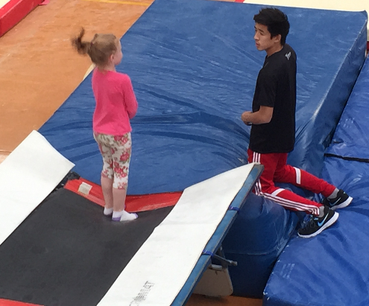
Wei Jun Lee – Life After Ollerup Scholarship
After my time at Ollerup I came back home to Wellington and a full time position at Capital Gymnastics. My role involved managing the Recreation Programs along with introducing Tumbling as a competitive sport. I started two new Tumbling squads pulling athletes from our existing Recreation classes and one year later I was offered a job in Sydney, Australia.

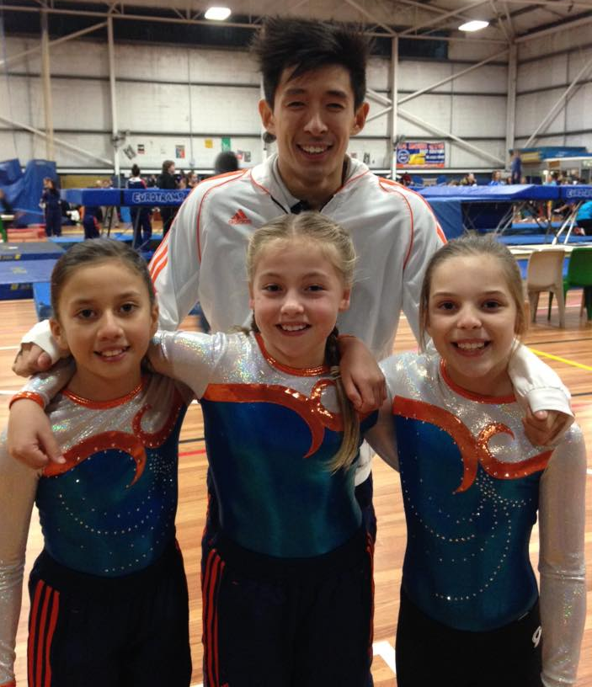
I went through a Skype interview and was accepted as a Tumbling Program Team Leader at Sydney Gymnastics and Aquatics Centre. I ran their existing competitive tumbling squads as well as introduced a few squads of my own. During my time at Sydney Gymnastics and Aquatics Centre I took on new opportunities like managing their Kinder Gym program (Pre-school gymnastics), I ran workshops to educate their staff and was voted coach of the year out of their 40 existing coaches. I worked at SGAC for one and a half years before I was offered to manage a new gymnastics centre from the ground up.
At first I actually turned down the offer but later realised the mistake and went back to see if the offer was still on the table. I’m glad I did as now four months into my new job and I love it! Within three months of running our gymnastics program we have over 300 recreational athletes and our competitive squad has taken out multiple titles. I have since been asked to educate the Gymnastics coaches and athletes within my clubs franchise name, PCYC, which is made up of over 60 clubs around New South Wales. Due to the rapid growth of the club I have been awarded as the Employee of the quarterly which includes all of the employees throughout all of the PCYC’s in the region.
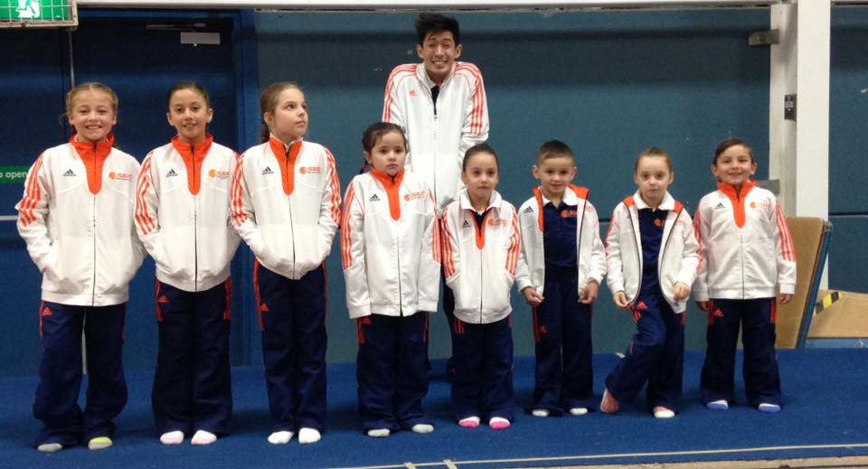
Taking the risk to leave SGAC, a well-established gym – the largest in Australia – to come to PCYC Auburn has opened up so many opportunities for me and was probably one of the SCARIEST decisions of my life. I believe that my success has largely to do with the amazing experience offered by Ollerup. I managed to discover myself and what kind of person I wanted to be during my time at the Danish boarding school. Along with learning new Gymnastics techniques and approaches plus the international experience Ollerup was the BEST decisions of my life

Update: Wei is now and FIG tumbling coach in Australia and taking athletes to World Champs. Wei has also been back to New Zealand as a presenter for Gymnastics NZ Gymschool in 2019.

Contact for any further Information:
Gymnastics New Zealand: (Central Region Relationship Manager)
Name: Megan Russell
Email: megan.russell@gymnasticsnz.com
Phone: 04 560 0440 or 027 653 1144
If you would like to talk to a previous recipient of this scholarship, please contact me on the above address and I can put you in touch with someone.

Ollerup – Academy of Physical Education
Website: www.ollerup.dk
Email: info@ollerup.dk
Brochure information: http://brochure-outsource-dk.com/ollerup_intac/intro/#p=1
Phone: (+45 6224 1230)

Application Form:
Please refer to the last 4 pages of this manual for your 20 week scholarship application form.

Gymnastics New Zealand Scholarship
Nomination Form for 2019 6 Month Ollerup Scholarship

Name of Applicant:

Email Address:

What is your skype name?

Cell Phone/ Contact Number:

Date of Birth:

Nominating Club:

Club contact:

Please make sure you have attached:

- Cover Letter from yourself

- Letter of reference from club

- Personal Letter of reference

Relevant gymnastics and leadership experience (eg competed for 4 years, now coaching general gymnastics classes 2 times a week) (separate sheet may be attached):

Reasons why I (the applicant) am suitable for the Scholarship to the Academy (separate sheet may be attached):

Before you leave/ On return to New Zealand you are required to volunteer time back to your club/ region – what would you like to do?

What are your future goals? Both within Gymnastic and in the wider world?

If you were selected what line would you like to study? TumblingX (Performance Tumbling), Parkour/ free running, Danish Rhythmic Gymnastics, Team Gym and Power Tumbling:

Please attach two photos of yourself – One a head shot and one of you either as an athlete or coaching in the club, please be aware these will be used on facebook and e-news if you are the successful applicant

Signed and dated:

____________________________ ________________________
On behalf of nominating club Applicant

