Mid Island Gym Sports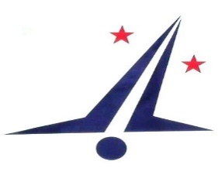
Mid Island Gym Sports (MIGS) is located on Te Ngae Road in Rotorua, we have a fully set up facility, which enables us to offer our community a wide variety of programmes, from Pre-school to recreation and competitive athletes in Artistic Gymnastics, Trampoline and Power Tumbling. We are currently looking for a:
Job Title: Head Coach for Womens Artistic Gymnastics
Qualification: Gymnastics NZ Junior Coach would be the preferred minimum
Job Description: This job requires the successful applicant to:
Have excellent coaching and communication skills
Have strong technical WAG skills and a commitment to excellence
Confident and positive with all gymnasts, no matter their ability or level
Enjoy working in a team environment and lead our team of WAG coaches
Is highly-organised and has proven preparation and class planning skills

Detailed terms and conditions of employment will be discussed with interested applicants.
Applications close on Friday 30th November 2018
To apply email your CV and an introduction letter to admin@migs.co.nz
Applicants for this position should have NZ residency or a valid NZ work visa.

