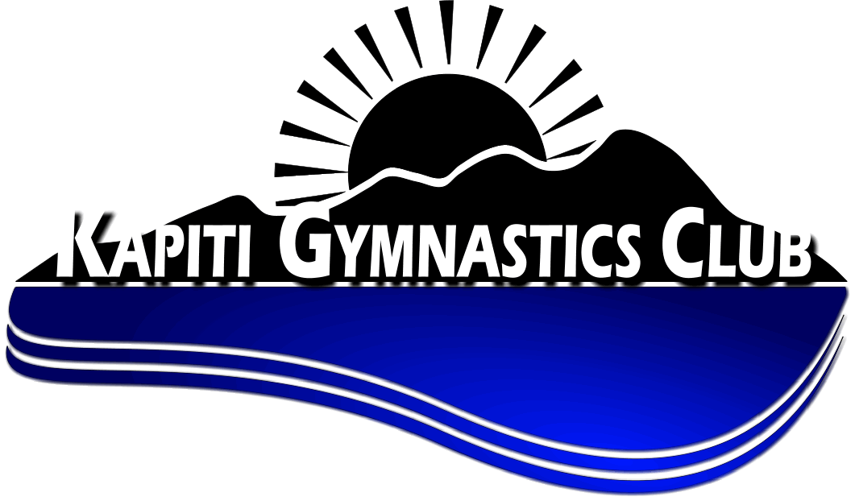

Kapiti Gymnastics Club is situated on the west side of the North Island approximately 40 minutes north of Wellington. It is a coastal community, but with easy and quick access to the Tararua ranges, so offers a variety of great recreational opportunities for those who love being in the outdoors. We have Kapiti Island bird sanctuary right on our door step. We have great schools and colleges all within easy walking distance of local communities. We are just a quick train ride away from Porirua and Wellington cities or under an hour’s drive to Palmerston North or the Hutt cities. We also have direct one-hour flights from Kapiti to Auckland. So, you can enjoy the benefits of the city and a relaxed life on the coast.

Kapiti Gymnastics club is housed in its own purpose-built facility, which we have just added an extension. We now have 740 square metre of gym space. We are situated in the middle of the Kapiti Coast so easily accessible to all.

Kapiti Gymnastics Club is seeking a part time (16 hours) WAG coach with a minimum qualification of elementary coach with at least 2 years’ experience coaching at that level. They must also be willing to undertake judging at competitions (but do not have to currently be a judge). This position would be coaching from pre-competitive through to Step4 and also assisting our competitive manager with higher steps. So, lots of opportunity to grow and develop.

We are looking for someone with a ‘can do attitude’. They must have a passion for gymnastics coaching and developing young people to be the best they can be.

Additional coaching hours would be available for the right person in general gym, schools and the opportunity to develop their own programmes such as Team Gym. For the person with the right skills there also maybe opportunity to undertake administration functions to further increase hours.

This position would primarily be working with our Manager Competitive Programme but could also be working with our General Gym Manager and have the opportunity to develop their own area in Team Gym. It is essential that they are a good team player and can work collaboratively with other areas of the Kapiti Gymnastics club.

Please email you covering letter outlining your suitability for the role and CV to treasurer@kapitigymnastics.co.nz. Application close at 5 pm Monday,12th November 2018.

